Demo Home Invasion Product

September 20, 2025

Safe Steps

ASSESSMENT

1. Surrounding Area
   1. Neighbors
      1. Home has neighbors on both left and right side and across the street, but none to the rear. Door to Door distance to closest neighbor is 40 meters. Limited direct line of sight to neighbors on left and right. Substantial direct line of sight to neighbors across street. Trees separate home from neighbors, but easily passible and no major obstacle separates home from neighbors.
   2. Geography
      1. Home has substantial dense woodlands to the rear, interspersed trees throughout property, and light vegetation between neighbors. Terrain is generally flat and well-manicured with no substantial landscape features serving as obstacles.
2. Perimeter Security
   1. Home has no fence. Home has no landscaping features that restrict foot travel. Rear of property backs up to dense woods with no easy vehicle access.
3. Entry Points
   1. Doors: Home has 3 doors: 2 inward-opening wooden doors, 1 sliding glass door, 1 garage door.
      1. Wall Hardware: Wooden doors are secured to wall with 3 joints, each with 3 1.5 inch screws.
      2. Lock Hardware: Wooden doors both have knob lock plus 1.5 inch dead bolt. Sliding door has handle latch and vertical catch
      3. Garage Door: Does not have external handle. Has external pin pad. Has remotely operated opening device. Internal door to house swings inward with just a knob lock.
4. Accessible Windows
   1. Ground floor has 9 accessible windows. All windows open vertically and contain plastic locks. Glass is approximately 1/4inch thick. All windows contain screens.
5. Current Security measures
   1. Technology: Home currently monitored by ADT system. System armed on all 9 ground floor windows and all 3 outside doors.
   2. Homeowner possesses two firearms. 2 Glock 19 9mm handguns are located in the master suite. Total of 90 rounds of ammunition are stored in the home. Total of 2 magazines are stored in the home.
6. Family
   1. Homeowners are 40 Male and 39 Female. Three children aged 4, 7, and 9.
7. Conclusion
   1. Home has no perimeter security and no access to neighbor overwatch. Neighbors are generally too far to be reached or of any help. Home has adequate police alerting technology, but no physical deterrents for invaders. No glass window will protect from shattering. External door wall fixtures are not sufficient. Garage door has no deterrent for sophisticated entries and internal garage door is a serious security weak point.

SIMULATED HOME INVASION

1. Infill
   1. Car parked between houses in dead zone of trees.
2. Entry point
   1. Kick in back door.
3. Movement through home
   1. Immediately go upstairs

SITUATION ALPHA: Middle of Night, everyone asleep

1. Mom and dad immediately wake each other.
2. Mom immediately gathers children from bedroom 2 and 4 and stages them in bedroom 3 in staging position.
3. Dad secures firearm from closet.
4. Dad turns hallway light on and assumes position at Strong Point 1 inside bedroom 2.
5. Mom calls 911, confirms police dispatch, and relays police the password.
6. Mom opens Window A to prepare for necessary escape route.
7. Dad remains at Strong Point 1 until police arrive.
8. Police Arrive and confirm password
9. Dad advises police to sweep floor 1
10. Police reach floor 2, dad moves to bedroom 3 and allows police to finish sweep

SITUATION BRAVO: Everybody awake

1. Mom immediately gathers children from bedroom 2 and 4 and stages them in bedroom 3 in staging position.
2. Dad secures firearm from closet.
3. Dad turns hallway light on and assumes position at Strong Point 1 inside bedroom 2.
4. Mom calls 911, confirms police dispatch, and relays police the password.
5. Mom opens Window A to prepare for necessary escape route.
6. Dad remains at Strong Point 1 until police arrive.
7. Police Arrive and confirm password
8. Dad advises police to sweep floor 1
9. Police reach floor 2, dad moves to bedroom 3 and allows police to finish sweep

SITUATION CHARLIE: One Parent Household

1. Mom immediately gathers children from bedroom 2 and 4 and stages them in bedroom 3 in staging position.
2. Dad secures firearm from closet.
3. Dad turns hallway light on and assumes position at Strong Point 1 inside bedroom 2.
4. Mom calls 911, confirms police dispatch, and relays police the password.
5. Mom opens Window A to prepare for necessary escape route.
6. Dad remains at Strong Point 1 until police arrive.
7. Police Arrive and confirm password
8. Dad advises police to sweep floor 1
9. Police reach floor 2, dad moves to bedroom 3 and allows police to finish sweep

IMPROVEMENT OPTIONS

1. Door stopper in Bedroom 3: $50
2. Fire ladder in Bedroom 3: $40
3. Flashlights in bedroom 3

REHEARSAL PLANS

1. Weekly rehearsal for 1 month
2. Monthly thereafter

911 SCRIPT

1. ASDF

COMMAND AND SIGNAL

1. Password Combo:
2. Safe word:

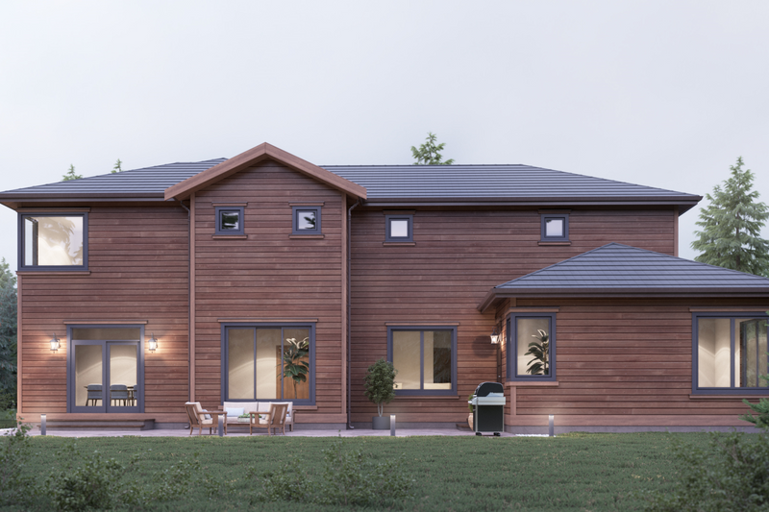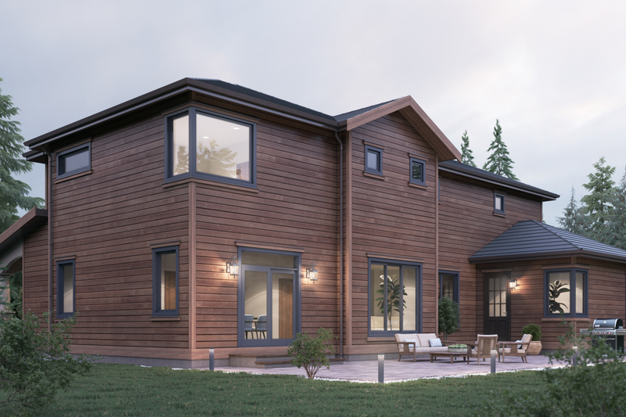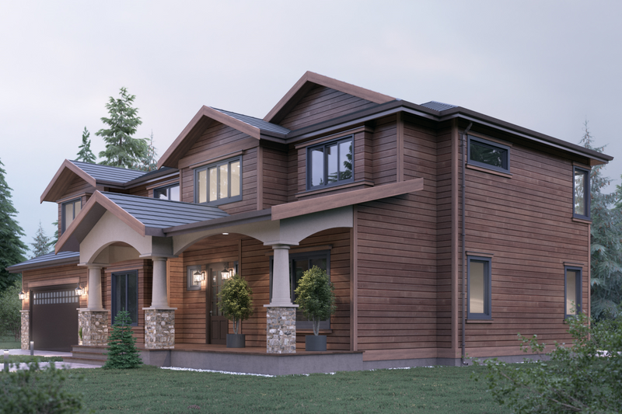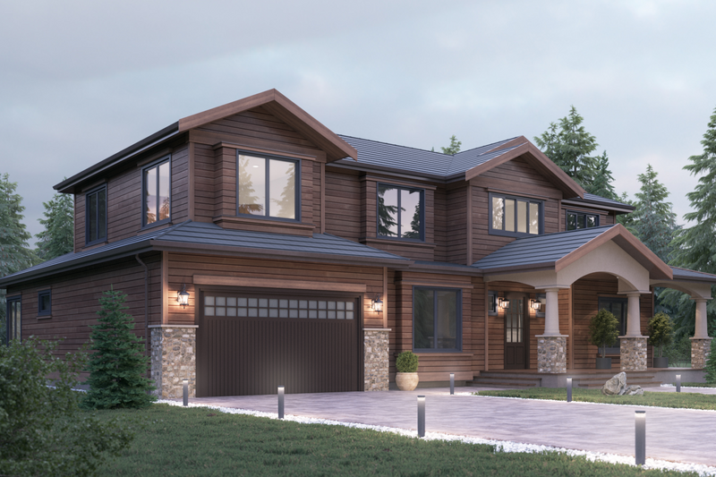

SP 1

Stage

area

SP 1